AI ASSISTED CODING
ASSIGMENT-13
NAME:K.POORNACHANDER
HALL.NUMBER:2403A52382
BATCH:AI 14
Task 1
- Task: Refactor repeated loops into a cleaner, more Pythonic approach.

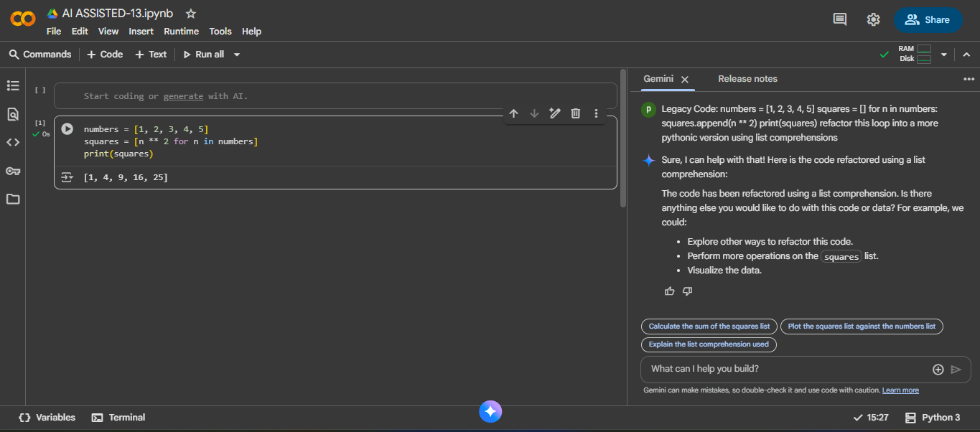

EXPLANITION:
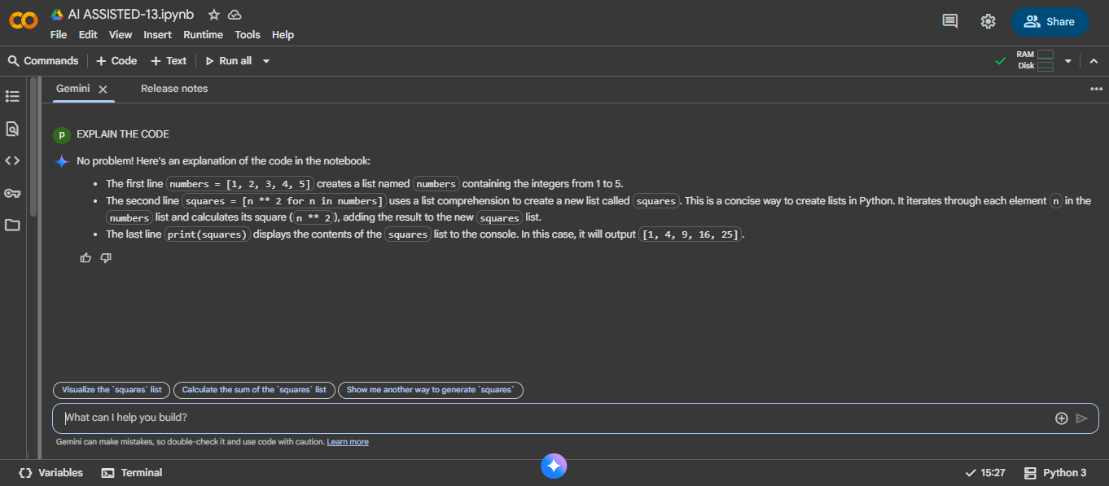
Task 2
Task: Simplify string concatenation.
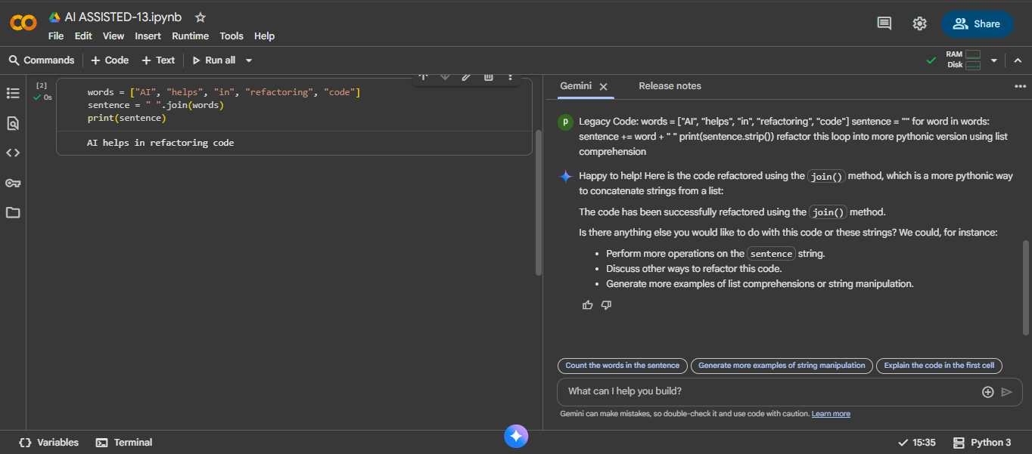

EXPLANITION:
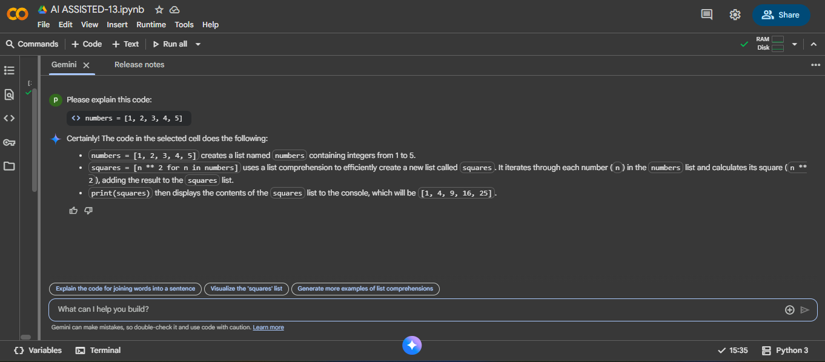
Task 3
Task: Replace manual dictionary lookup with a safer method.
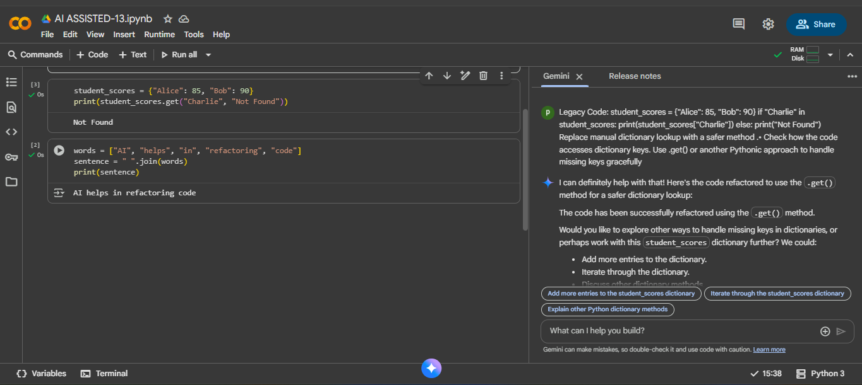

EXPLANITION:
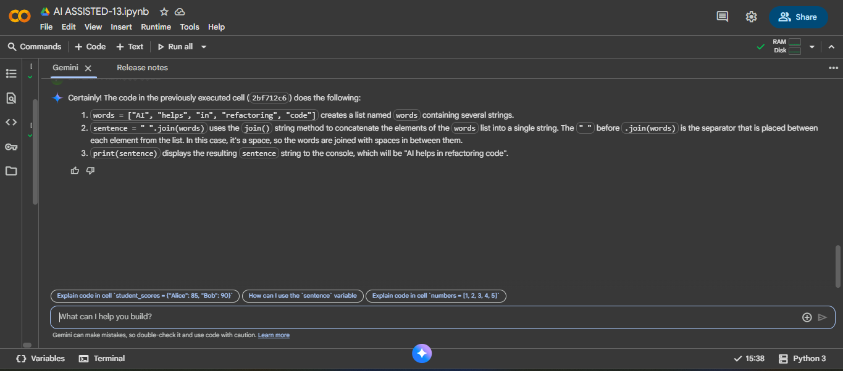
Task 4
Task: Refactor repetitive if-else blocks.
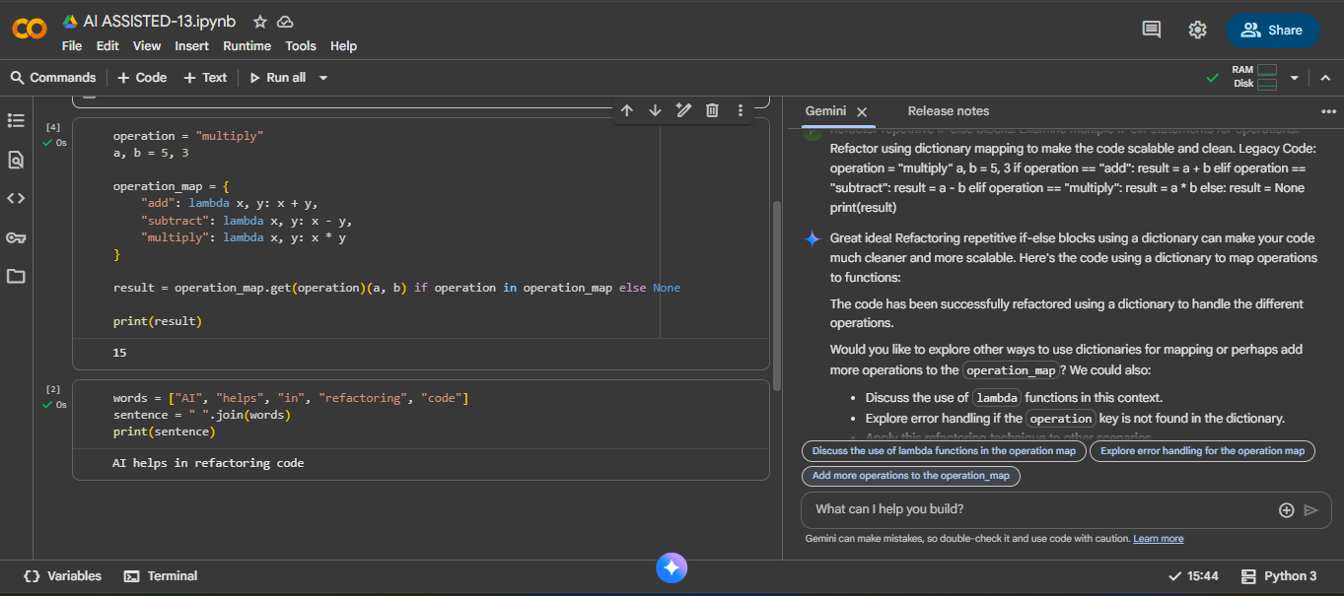

EXPLANITION:
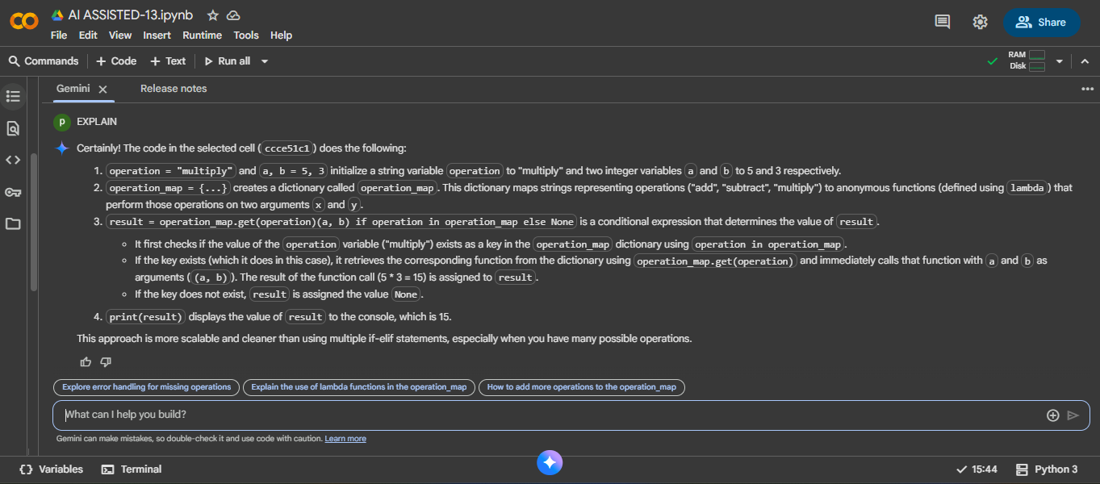
Task 5
Task: Optimize nested loops for searching.
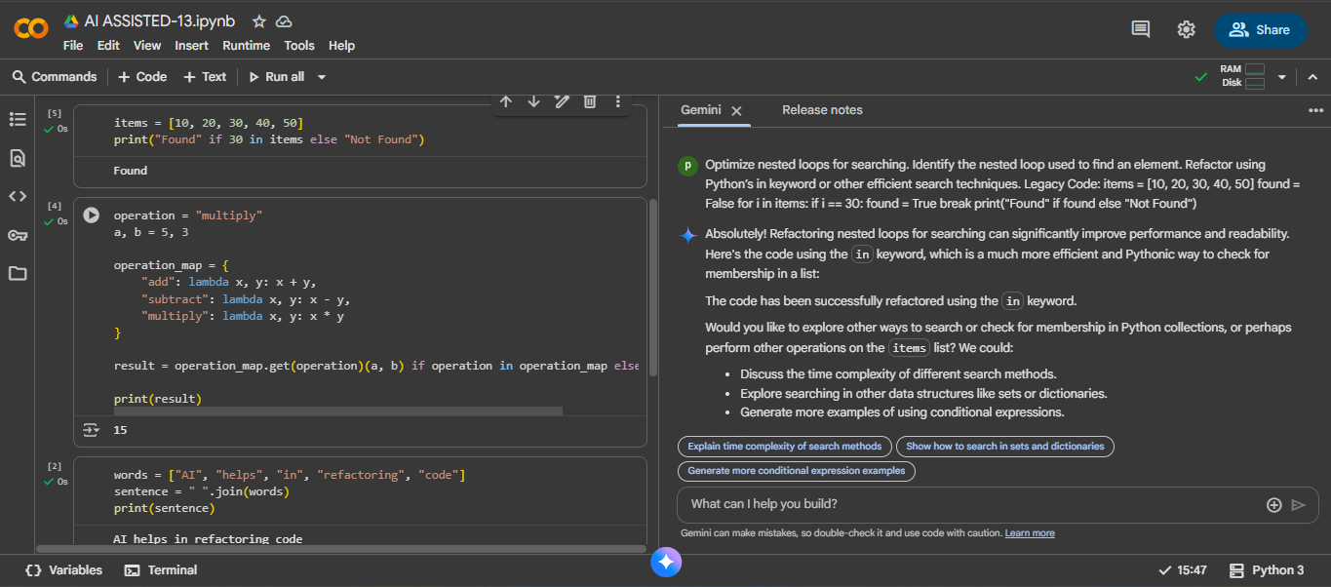

EXPLANITION:
